Code:

**ContactPage.js**

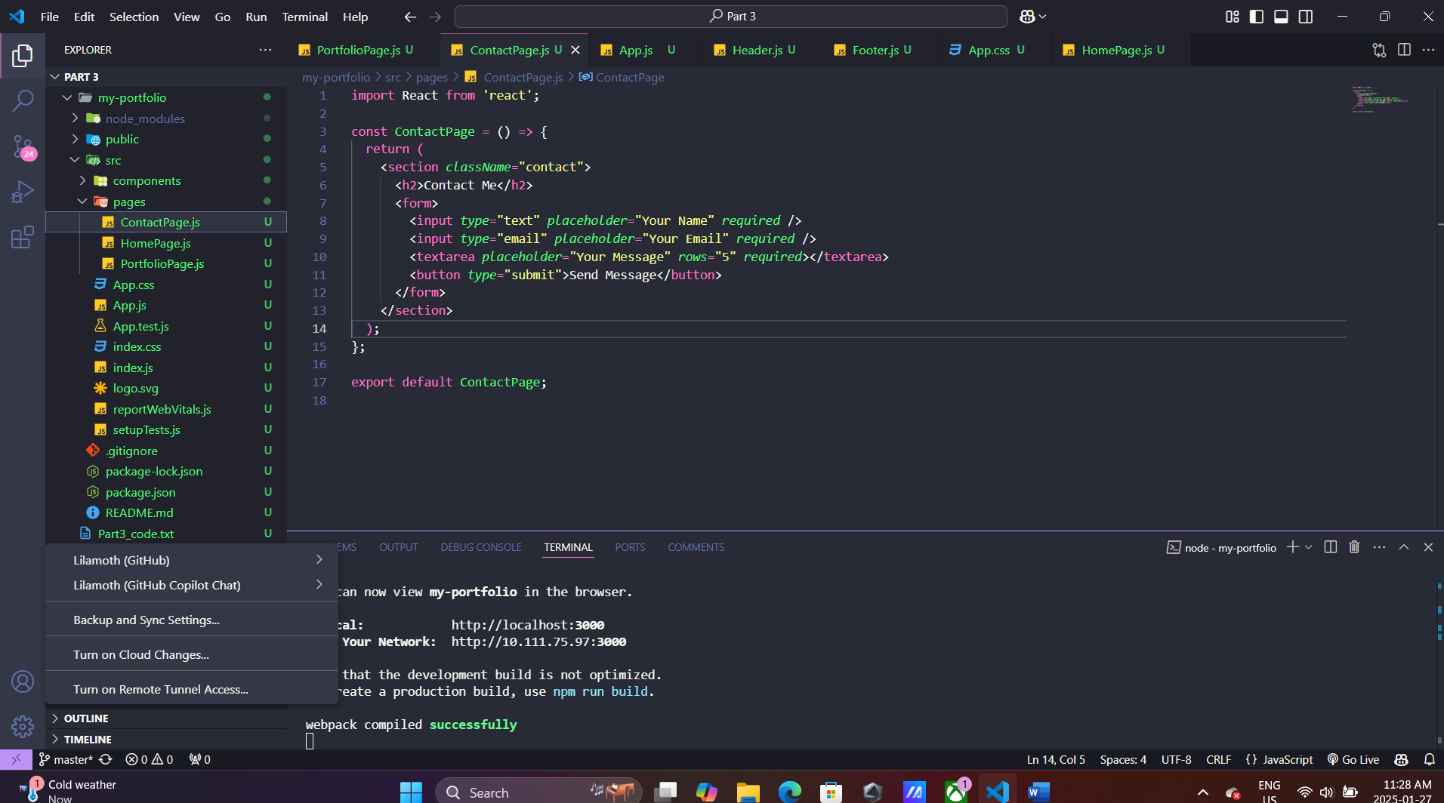

**HomePage.js**

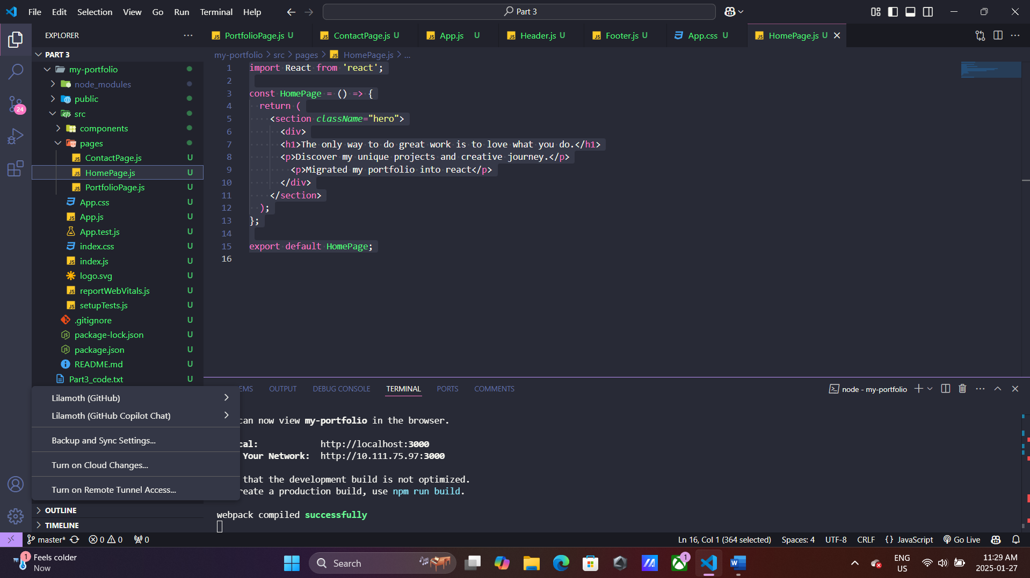

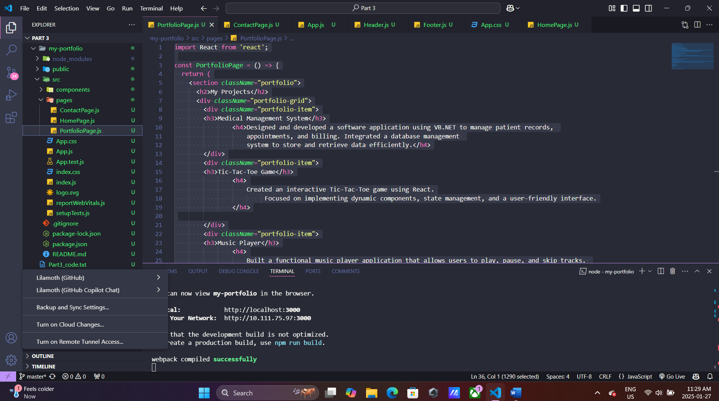

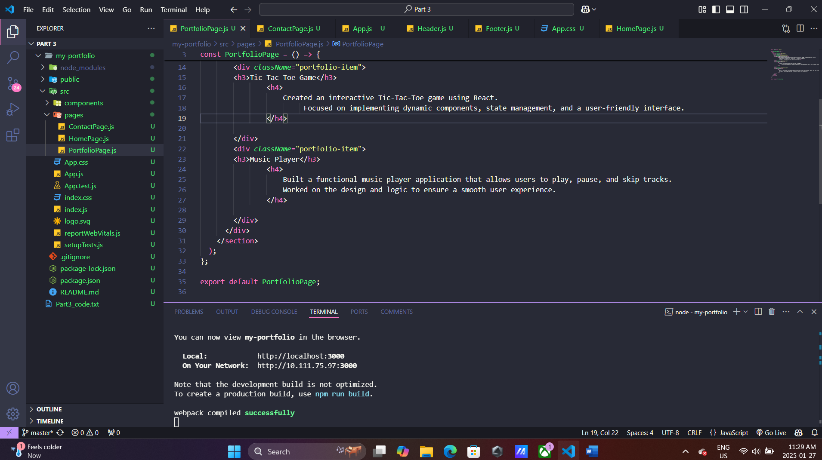

**App.css**

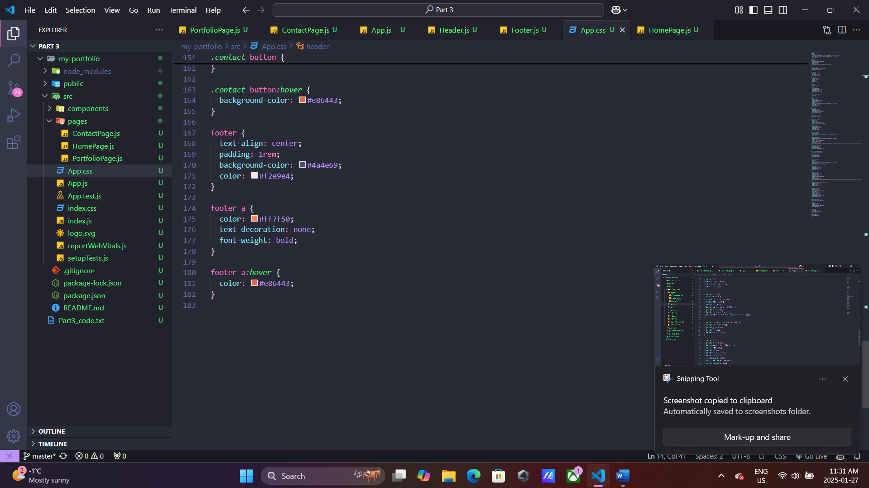

**Output:**



